SAVEETHA SCHOOL OF ENGINEERING  
 SAVEETHA INSTITUTE OF MEDICAL AND TECHNICAL SCIENCES  
 ITA 0443 - STATISTICS WITH R PROGRAMMING FOR REAL TIME PROBLEM

DAY 4– LAB MANUAL

Reg No:192125052  
Name: S. Nethreshwar

LINEAR REGRESSION ANALYSIS IN R

Exercise :

1. Using linear regression analysis establish a relationship between height and weight of a  
person using the input vector given below.  
# Values of height  
151, 174, 138, 186, 128, 136, 179, 163, 152, 131  
# Values of weight.  
63, 81, 56, 91, 47, 57, 76, 72, 62, 48  
Predict the weight of a person with height 170. Visualize the regression graphically.

PROGRAM:

x <- c(151, 174, 138, 186, 128, 136, 179, 163, 152, 131)

y <- c(63, 81, 56, 91, 47, 57, 76, 72, 62, 48)

relation <- lm(y~x)

# Give the chart file a name.

png(file = "linearregression.png")

# Plot the chart.

plot(y,x,col = "blue",main = "Height & Weight Regression",

abline(lm(x~y)),cex = 1.3,pch = 16,xlab = "Weight in Kg",ylab = "Height in

cm")

# Save the file.

dev.off()

# Plot the chart.

plot(y,x,col = "blue",main = "Height & Weight Regression",

abline(lm(x~y)),cex = 1.3,pch = 16,xlab = "Weight in Kg",ylab = "Height in

cm")

output :

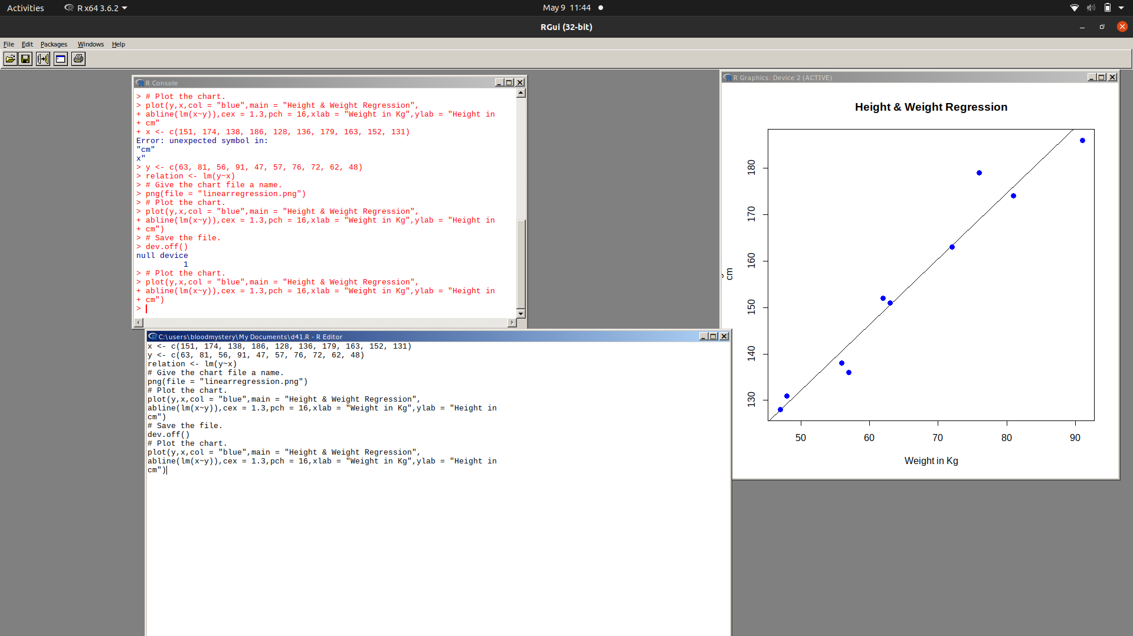

2. Download the Dataset "water" From Rdataset Link.Find out whether there is a linear  
relation between attributes"mortality" and"hardness" by plot function.Fit the Data into the  
Linear Regression model.Predict the mortality for the hardness=88

PROGRAM:

iinstall.packages("dslabs")

library(dslabs)

data(water)

plot(water$hardness, water$mortality, main = "Scatter plot of Mortality vs.

Hardness",

xlab = "Hardness", ylab = "Mortality")

model <- lm(mortality ~ hardness, data = water)

summary(model)

new_data <- data.frame(hardness = 88)

predicted_mortality <- predict(model, newdata = new_data)

predicted_mortality

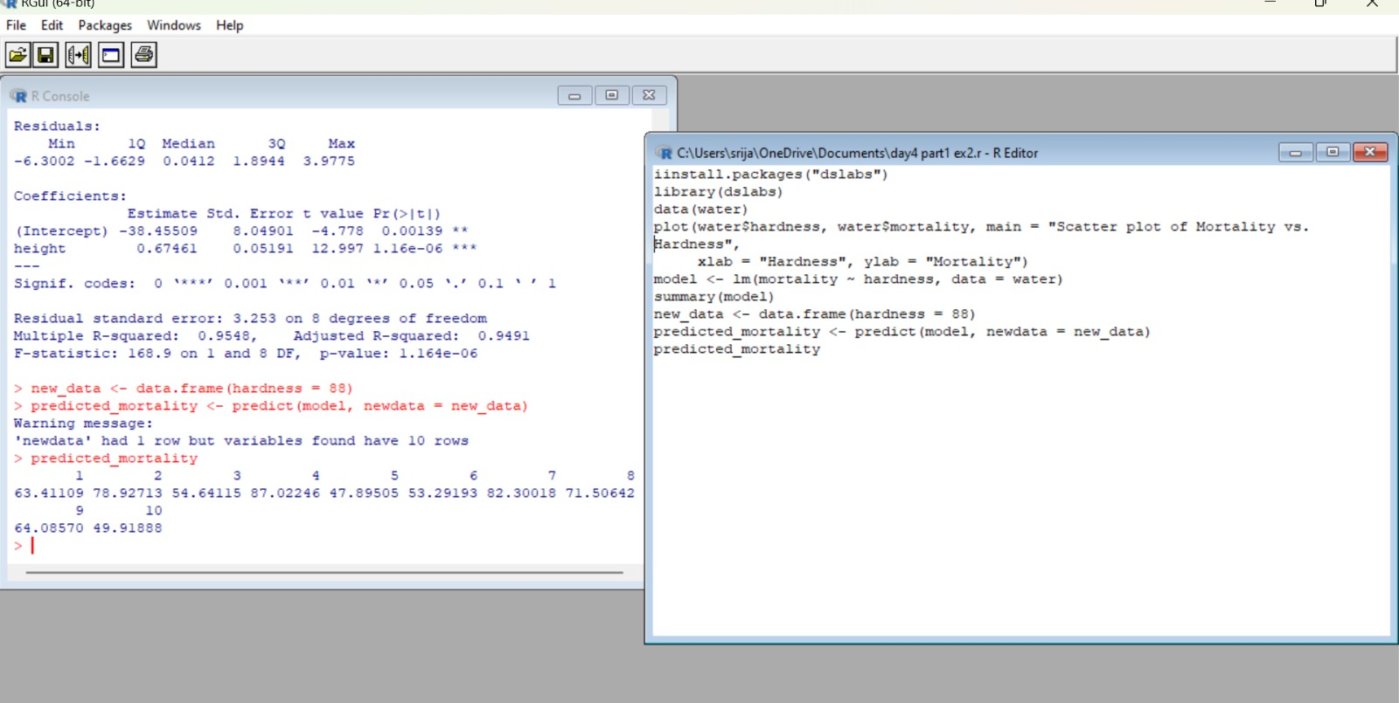

MULTIPLE REGRESSION ANALYSIS IN R  
Exercise:

3.Generate a multiple regression model using the built in dataset mtcars.It gives a comparison  
between different car models in terms of mileage per gallon (mpg), cylinder  
displacement("disp"), horse power("hp"), weight of the car("wt") and some more parameters.  
Establish the relationship between "mpg" as a response variable with "disp","hp" and "wt" as  
predictor variables. Predict the mileage of the car with dsp=221,hp=102 and wt=2.91.

PROGRAM:

data(mtcars)

model <- lm(mpg ~ disp + hp + wt, data = mtcars)

summary(model)

new_data <- data.frame(disp = 221, hp = 102, wt = 2.91)

predicted_mpg <- predict(model, newdata = new_data)

predicted_mpg

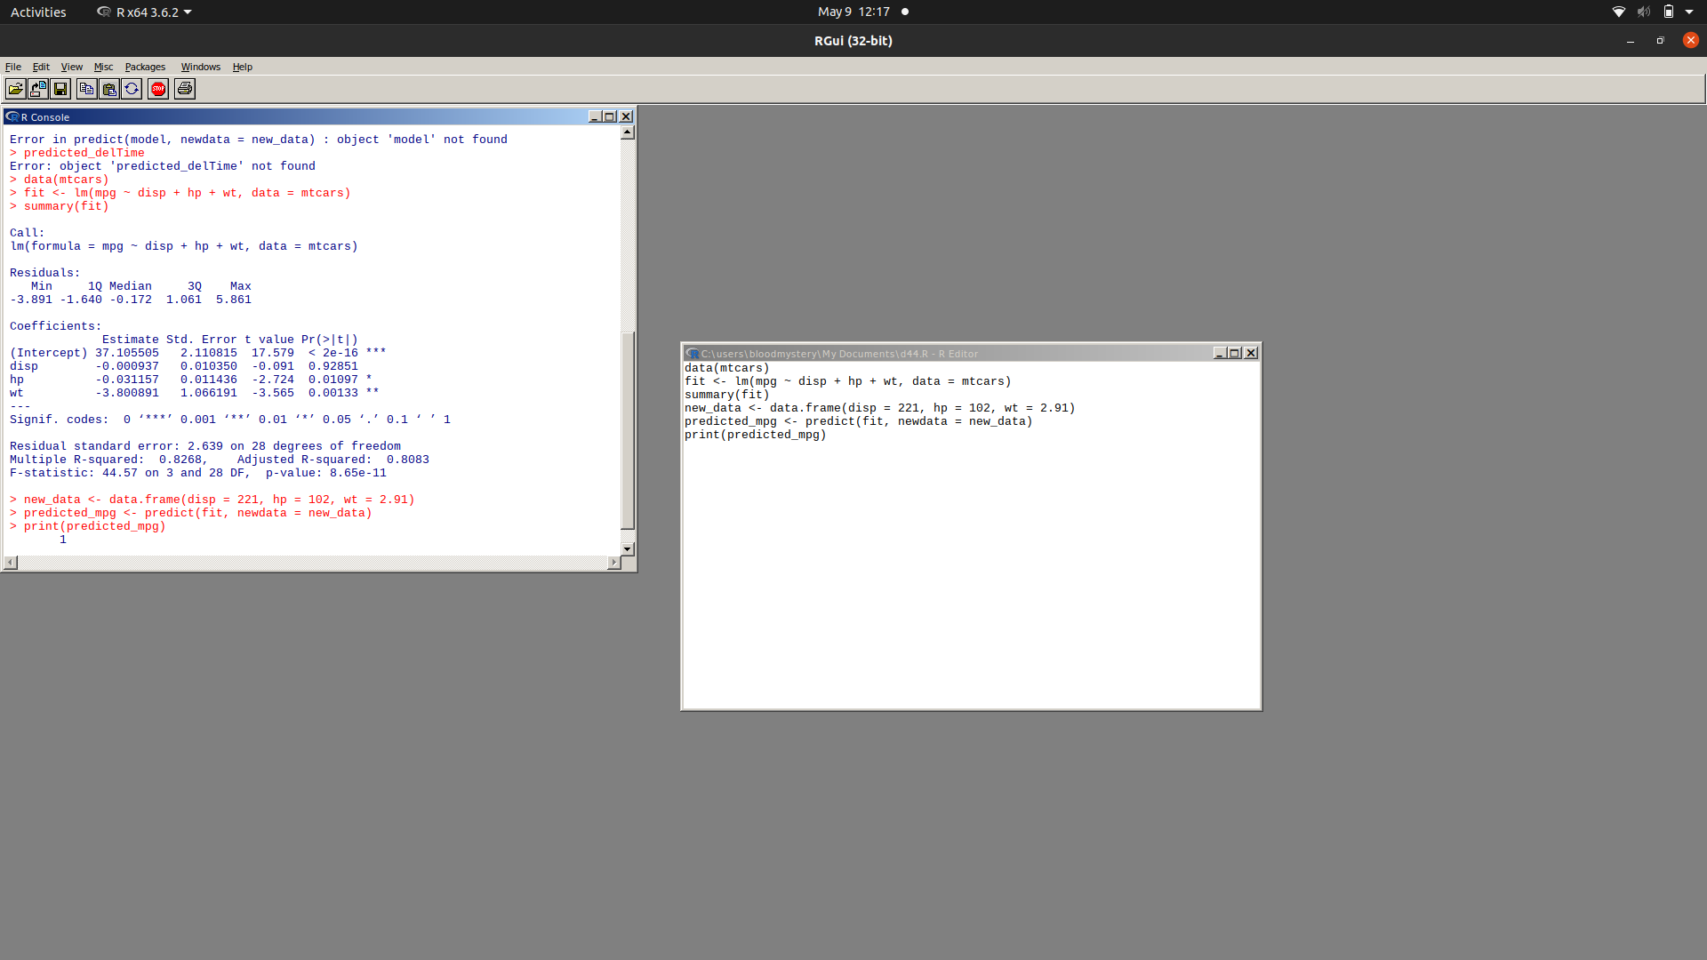

4. Consider the data set "delivery" available in the R environment. It gives a deliverytime  
(“delTime”)of production materials(number of productions “n.prod”) with the given  
distance(“distance”) to reach the destination place.

a)Create the model to establish the relationship between "delTime" as a response  
variable with "n.prod" and "distance" as predictor variables.  
b)Predict the delTime for the given number of production(“n.prod”)=9 and  
distance(“distance”)=450

PROGRAM:

data(delivery)

model <- lm(delTime ~ n.prod + distance, data = delivery)

summary(model)

new_data <- data.frame(n.prod = 9, distance = 450)

predicted_delTime <- predict(model, newdata = new_data)

predicted_delTime

